WEB DEVELOPMENT
PROJECT REPORT
A Collection of HTML and CSS Mini Projects

Submitted by: G.LOKESH
University: DR. RVR NRI UNIVERSITY
Course: B.Tech – CSE (AI & ML)
Year: First Year

Academic Project Submission

Project Overview
This report documents three beginner-level web pages submitted together as a Web Development mini-project collection. The supplied files represent a restaurant menu page, a personal hobbies page, and a basic audio webpage. The source files are presented without rewriting their original markup.

Project Titles
- Delicious Restaurant – a restaurant information and menu webpage.
- My Hobbies – a personal webpage describing interests and leisure activities.
- Audio Webpage – a basic HTML audio-player example (the supplied file currently has markup and media-reference issues).

1. Introduction
Web development is the process of creating webpages that present information in a structured and visually clear manner. This project collection demonstrates the basic use of HTML to organize webpage content and CSS to control its appearance. The three supplied pages cover different simple use cases: displaying a restaurant menu, presenting personal hobbies, and attempting to embed an audio player.
The purpose of the work is to practise HTML elements such as headings, paragraphs, lists, divisions, images and audio, along with CSS properties for colors, spacing, borders, typography and layout.

2. Objectives
- Understand the basic structure of an HTML document.
- Use headings, paragraphs, ordered lists, unordered lists and division elements to organize content.
- Apply CSS styles to control colors, fonts, spacing, borders and alignment.
- Display a local image in a webpage using the HTML image element.
- Explore the HTML audio element and identify the resources required for media playback.
- Render webpages in a browser and explain the visible output.

3. Technologies Used

HTML5
HTML is used to define the structure and content of the webpages. The supplied code uses elements such as html, head, title, body, h1, h2, p, div, ul, ol, li, img, audio and source.

CSS3
CSS is used inside style elements in the Restaurant Menu and My Hobbies HTML files. It controls fonts, background colors, text colors, margins, padding, borders, rounded corners, image dimensions and text alignment. No separate .css stylesheet was supplied.

Additional technologies
No JavaScript, database, backend framework or external CSS framework is used in the supplied source. The audio page attempts to use an MP3 resource, but the referenced audio file was not included.

4. Webpage Description

4.1 Delicious Restaurant
The Restaurant Menu page is designed to present a restaurant's identity, food categories, prices and contact details. Its browser title is “Restaurant Menu”. The page uses Arial text and a warm light-cream background (#fff3e0).
- Header: a brown banner with the white centered heading “Delicious Restaurant” and the tagline “Fresh Food, Great Taste!”.
- About Us: a white rounded section with a brown border and a short restaurant introduction.
- Starters: an unordered list containing Veg Soup, French Fries and Paneer Tikka with prices.
- Main Course: an ordered list containing Veg Biryani, Chicken Biryani and Paneer Curry with prices.
- Desserts: an unordered list containing Ice Cream, Chocolate Cake and Gulab Jamun with prices.
- Our Special Food: a section displaying the supplied food photograph. The image is sized to 300 × 200 pixels and has an orange border with rounded corners.
- Contact Us: displays the Vijayawada, Andhra Pradesh address and a phone number as written in the source.
- Footer: a brown banner containing “Thank you for visiting!”.
The sections are separated by margins and padding. Each content section has a white background, a 2-pixel brown border and rounded corners. The page does not contain a navigation bar or interactive menu buttons.

4.2 My Hobbies
The My Hobbies page introduces personal interests and explains why hobbies are useful. Its browser title is “My Hobbies”. The body uses Arial/sans-serif text, a light-blue background and 20-pixel outer margin.
- Main heading: “My Hobbies” is centered in dark blue on a light-yellow background with padding.
- Introduction: a white rounded section describing hobbies and their benefits.
- Reading Books: a section explaining that reading storybooks and novels improves knowledge and vocabulary.
- Playing Sports: a section describing outdoor games and their role in keeping a person healthy and active.
- My Favorite Hobbies: an unordered list of reading books, listening to music, playing cricket, drawing pictures and watching movies.
- Footer: a dark-blue banner containing “Thank you for visiting my webpage!”.
The section boxes have white backgrounds, gray borders and rounded corners. Section headings are dark green with green bottom borders. Paragraph text is 18 pixels and uses a line height of 1.5. List text is brown and 18 pixels. In the supplied CSS, the paragraph rule sets a dark text color, which also affects the footer paragraph; the screenshot preserves this behavior.

4.3 Audio Webpage
The file Untitled-1.html appears intended to demonstrate an HTML audio control for a song. It contains an audio element with controls and a source element whose path is written as “kannappa akasha veedhilo song mp3”. No matching MP3 file was supplied. The page also contains malformed HTML syntax, including an incomplete doctype declaration, an incomplete html start tag, a misplaced body closing tag, a misspelled autoplay attribute and an incomplete source tag. As supplied, the page renders as a blank page in the captured output and does not provide a working audio player.
The original source is retained in the source-code section. No corrections have been silently applied.

5. Actual Webpage Output
The following images are rendered from the supplied HTML files with their embedded CSS and the supplied local food image. The screenshots show the page content and styling produced by the provided source. The audio page is shown as rendered because its current source does not produce a visible player.

5.1 Restaurant Menu – Rendered Output
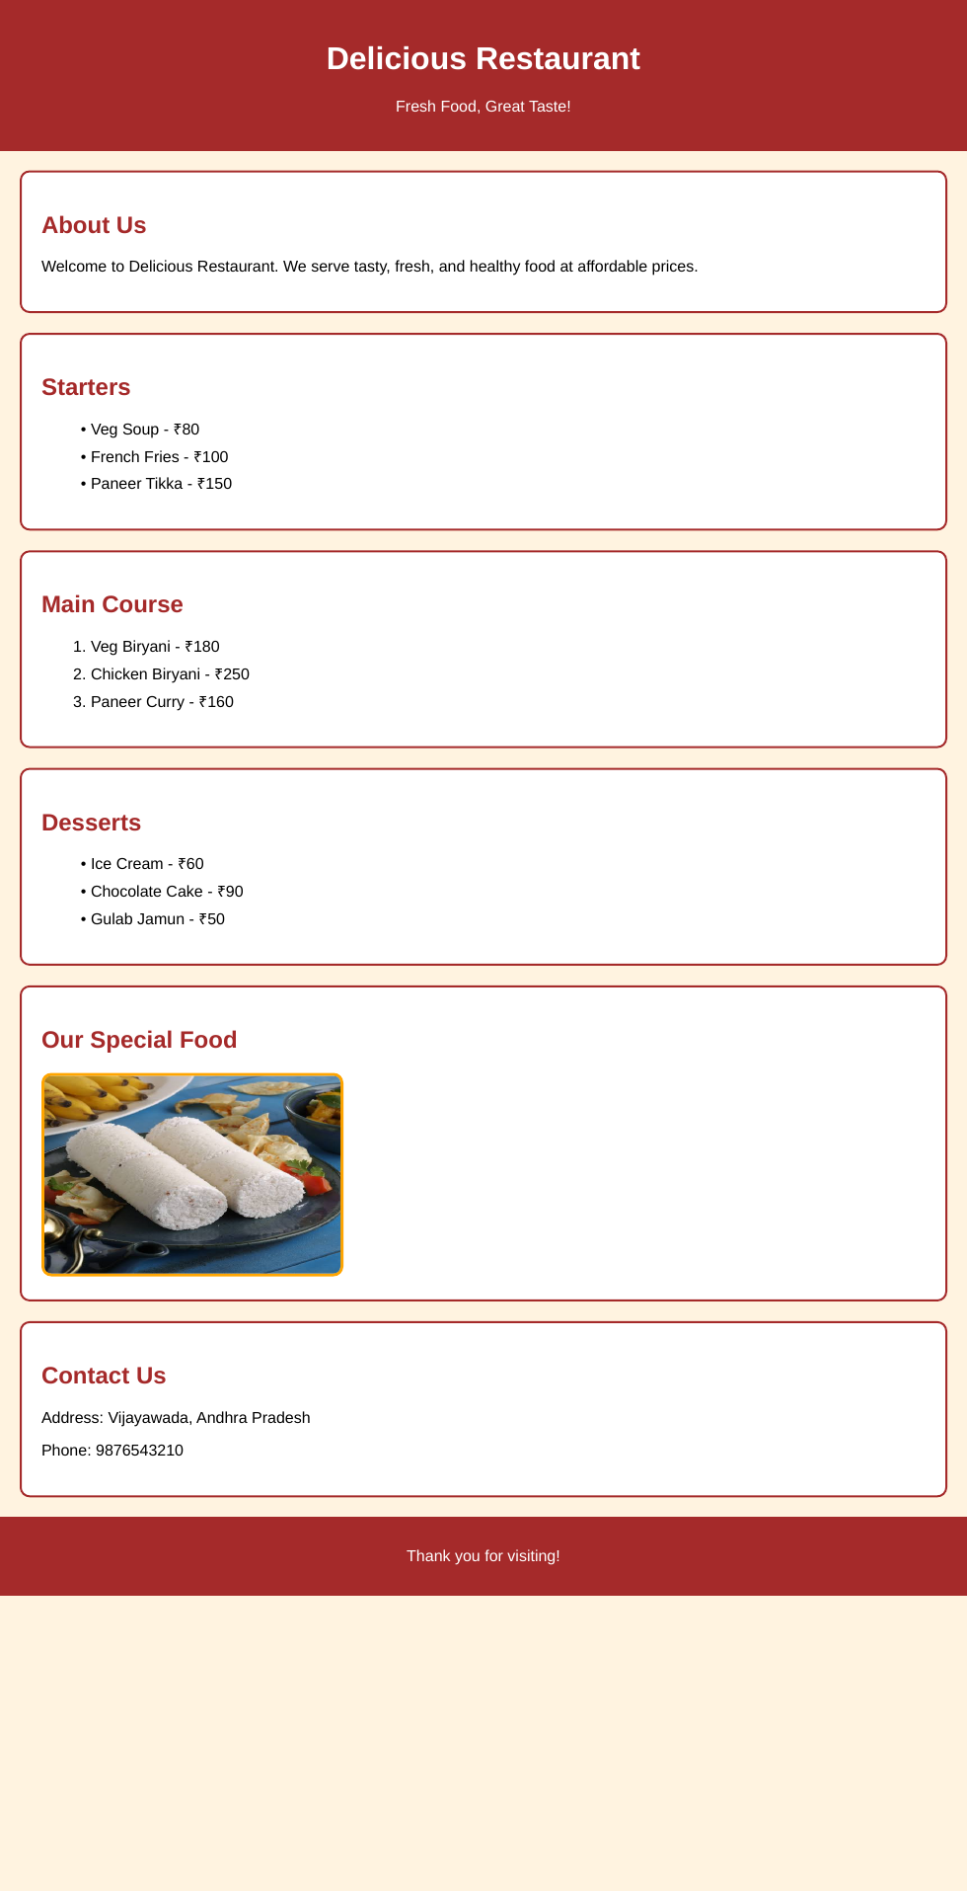
Figure 1. Rendered output of the Delicious Restaurant webpage.

5.2 My Hobbies – Rendered Output
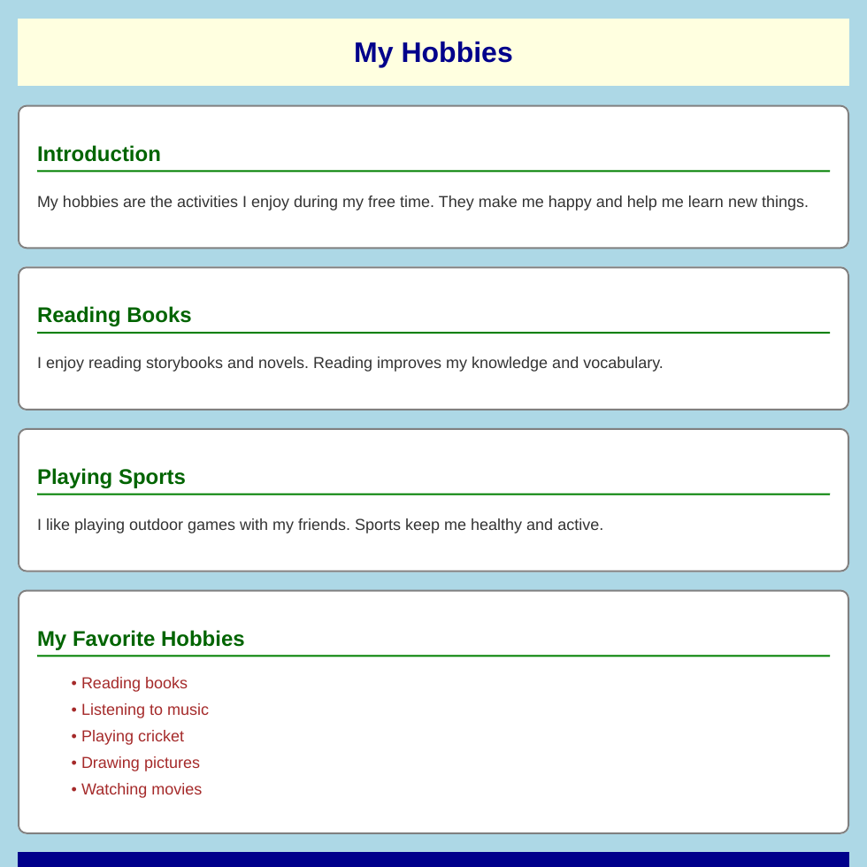
Figure 2. Rendered output of the My Hobbies webpage.

5.3 Audio Webpage – Rendered Output

Figure 3. Rendered output of Untitled-1.html as supplied (blank page).
The blank output is not an intentionally designed page. It reflects the malformed HTML and unavailable audio resource in the supplied file.

6. Output Explanation

Restaurant Menu output
The output displays a full-width brown title area followed by stacked white content panels on a light-cream page. The food categories are easy to distinguish because each has its own heading and list. The special-food photograph appears inside a bordered panel. The contact details are placed near the bottom, followed by the brown footer.

My Hobbies output
The output displays a centered title on a light-yellow strip. Four white content panels appear vertically on the light-blue background. Green section headings and their underline borders create visual separation, while the favorite hobbies are displayed as a brown bullet list. A dark-blue footer appears at the bottom.

Audio webpage output
No visible content appears in the supplied rendering. The audio player cannot be verified because the HTML is malformed and the referenced MP3 file is missing. A corrected version and the correct audio asset would be needed to demonstrate playback.

7. Source Code
The complete source of each supplied HTML file is reproduced below. CSS is embedded in the style element of the Restaurant Menu and My Hobbies files; therefore, those style rules are included as part of the respective HTML source. The code is reproduced as provided, without correction.

7.1 Untitled-1.html – Audio Webpage
<DOCTYPE html>
<html lang="eng"
<head>
<title> wed page </title>
</head>
</body>
<audio autuplay controls>
<source src="kannappa akasha veedhilo song mp3" type="audio/mpeg"
your browser does not support audio
</audio>
</body>
</html>

7.2 restorent.html – Restaurant Menu
<!DOCTYPE html>
<html>
<head>
<title>Restaurant Menu</title>
<style>
body {
font-family: Arial;
background-color: #fff3e0;
margin: 0;
padding: 0;
}
.header {
background-color: brown;
color: white;
text-align: center;
padding: 20px;
}
.section {
background-color: white;
margin: 20px;
padding: 20px;
border: 2px solid brown;
border-radius: 10px;
}
h2 {
color: brown;
}
.food-image img {
width: 300px;
height: 200px;
border: 3px solid orange;
border-radius: 10px;
}
li {
margin: 10px;
}
.footer {
background-color: brown;
color: white;
text-align: center;
padding: 15px;
}
</style>
</head>
<body>
<div class="header">
<h1>Delicious Restaurant</h1>
<p>Fresh Food, Great Taste!</p>
</div>
<div class="section">
<h2>About Us</h2>
<p>Welcome to Delicious Restaurant.
We serve tasty, fresh, and healthy food
at affordable prices.</p>
</div>
<div class="section">
<h2>Starters</h2>
<ul>
<li>Veg Soup - ₹80</li>
<li>French Fries - ₹100</li>
<li>Paneer Tikka - ₹150</li>
</ul>
</div>
<div class="section">
<h2>Main Course</h2>
<ol>
<li>Veg Biryani - ₹180</li>
<li>Chicken Biryani - ₹250</li>
<li>Paneer Curry - ₹160</li>
</ol>
</div>
<div class="section">
<h2>Desserts</h2>
<ul>
<li>Ice Cream - ₹60</li>
<li>Chocolate Cake - ₹90</li>
<li>Gulab Jamun - ₹50</li>
</ul>
</div>
<div class="section food-image">
<h2>Our Special Food</h2>
<img src="retorent.jpg"
alt="Delicious food">
</div>
<div class="section">
<h2>Contact Us</h2>
<p>Address: Vijayawada, Andhra Pradesh</p>
<p>Phone: 9876543210</p>
</div>
<div class="footer">
<p>Thank you for visiting!</p>
</div>
</body>
</html>

7.3 my hobbies.html – My Hobbies
<!DOCTYPE html>
<html>
<head>
<title>My Hobbies</title>
<style>
body {
font-family: Arial, sans-serif;
background-color: lightblue;
margin: 20px;
}
h1 {
color: darkblue;
text-align: center;
background-color: lightyellow;
padding: 20px;
}
h2 {
color: darkgreen;
border-bottom: 2px solid green;
padding-bottom: 5px;
}
p {
font-size: 18px;
color: #333333;
line-height: 1.5;
}
.section {
background-color: white;
margin: 20px 0;
padding: 20px;
border: 2px solid gray;
border-radius: 10px;
}
ul {
color: brown;
font-size: 18px;
}
li {
margin: 10px;
}
.footer {
text-align: center;
background-color: darkblue;
color: white;
padding: 10px;
}
</style>
</head>
<body>
<h1>My Hobbies</h1>
<div class="section">
<h2>Introduction</h2>
<p>My hobbies are the activities I enjoy
during my free time. They make me happy
and help me learn new things.</p>
</div>
<div class="section">
<h2>Reading Books</h2>
<p>I enjoy reading storybooks and novels.
Reading improves my knowledge and vocabulary.</p>
</div>
<div class="section">
<h2>Playing Sports</h2>
<p>I like playing outdoor games with my friends.
Sports keep me healthy and active.</p>
</div>
<div class="section">
<h2>My Favorite Hobbies</h2>
<ul>
<li>Reading books</li>
<li>Listening to music</li>
<li>Playing cricket</li>
<li>Drawing pictures</li>
<li>Watching movies</li>
</ul>
</div>
<div class="footer">
<p>Thank you for visiting my webpage!</p>
</div>
</body>
</html>

8. Files and Resource Notes
- retorent.jpg: this image is referenced by the Restaurant Menu page and appears in its rendered output.
- images.jpg: this building photograph was supplied but is not referenced by any of the three HTML files, so it is not displayed in the webpage screenshots.
- Separate CSS files: none were supplied. CSS is embedded inside the two HTML files that contain styling.
- Audio file: the MP3 referenced in Untitled-1.html was not supplied, so audio playback could not be tested.
- HTML validation: Untitled-1.html contains syntax issues. They are documented here, but the original source has been preserved in the code listing.

9. Conclusion
Through this project collection, I practised creating webpages with HTML and styling them with CSS. I learned how to organize information using headings, paragraphs and lists, how to display images, and how to improve page appearance using colors, spacing, borders and alignment. I also understood that media elements need valid HTML markup and the correct resource files to work properly. This project helped me develop a foundation for building more structured and interactive websites in future web development work.

10. Future Improvements
- Add a navigation bar and responsive layout to the Restaurant Menu and My Hobbies pages.
- Move embedded CSS into separate stylesheet files for easier maintenance.
- Add the missing MP3 file and correct the HTML structure and audio attributes in the audio webpage.
- Add mobile-friendly styling using CSS media queries.
- Improve accessibility with valid language attributes, meaningful alternative text and semantic HTML elements.

